ADVANCE DEVOPS EXP-9

**MANORATH ITAL D15A/19**

**Aim:** To Understand Continuous monitoring and Installation and configuration of Nagios Core, Nagios Plugins and NRPE (Nagios Remote Plugin Executor) on Linux Machine.

**Step-1:**Login to your AWS account Personal / Academy. Click on EC2 instance then click on Create Security Group. Give the name as Nagios and any description and add the following inbound rules.

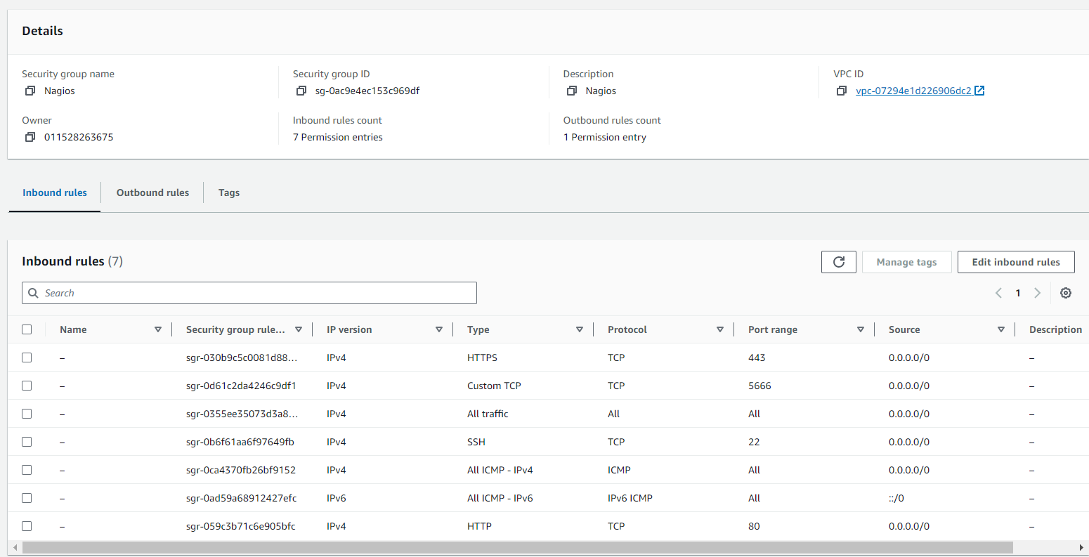

**Step 2:** Now Create a new EC2 instance. Name: Nagios-host ,AMI: Amazon Linux, Instance Type: t2.micro.

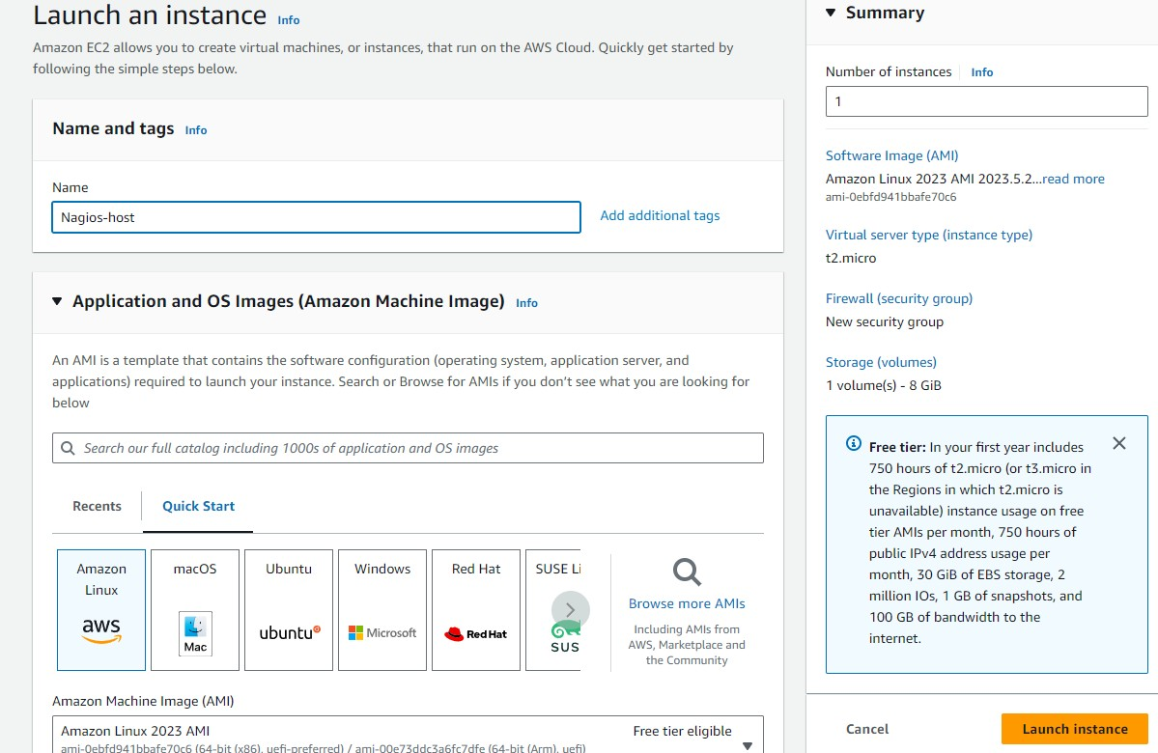

**For Key pair :** Click on create key and make key of type RSA with extension .pem . Key will be downloaded to your local machine and select the **Existing Security Group** and select the Security Group we have created in Step 1.

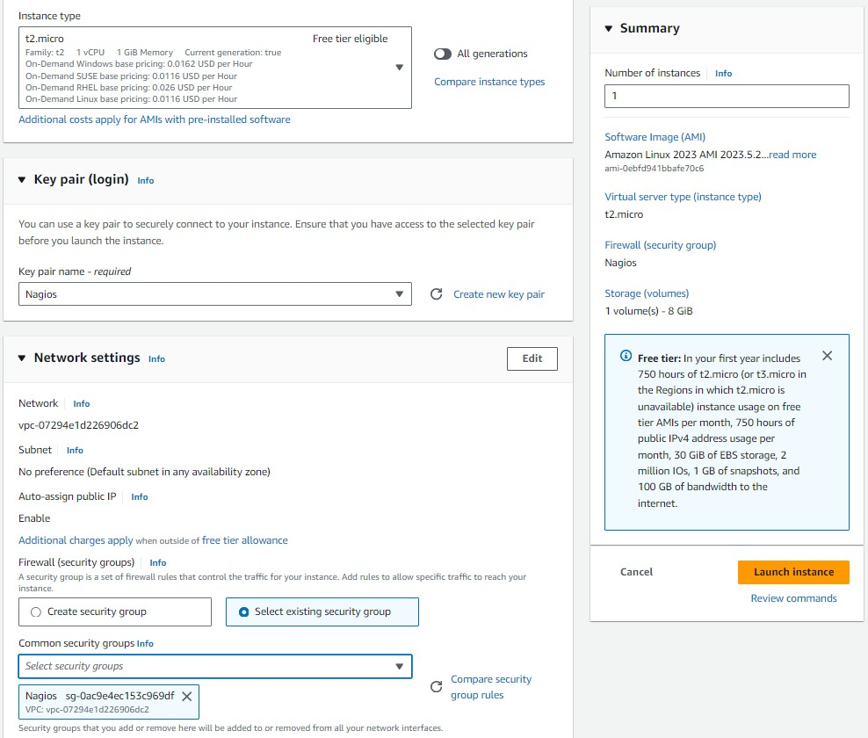

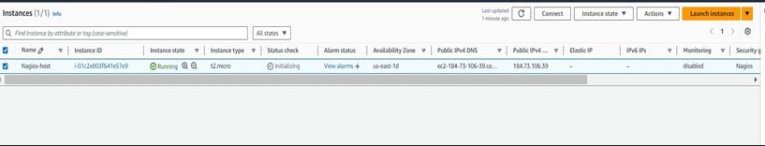

**Step 3:** Now After creating the EC2 Instance click on connect and then copy the command which is given as example in the SSH Client section .

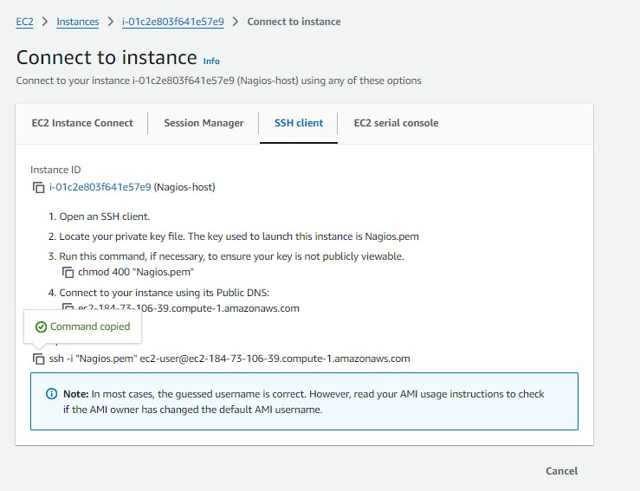

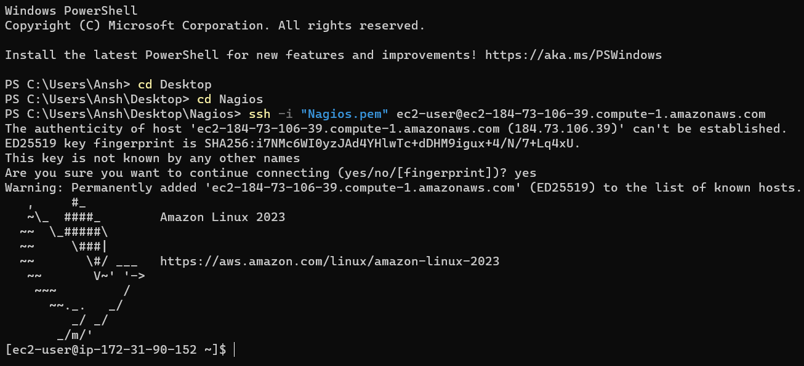Successfully connected to the instance.

**Step 4:** Now Run the following command to make a new user.- sudo adduser -m nagios sudo passwd nagios

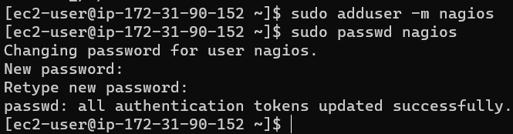

**Step 5:** Now Run the following command to make a new user group. sudo groupadd nagcmd ,

sudo usermod -a -G nagcmd nagios, sudo usermod -a -G nagcmd apache

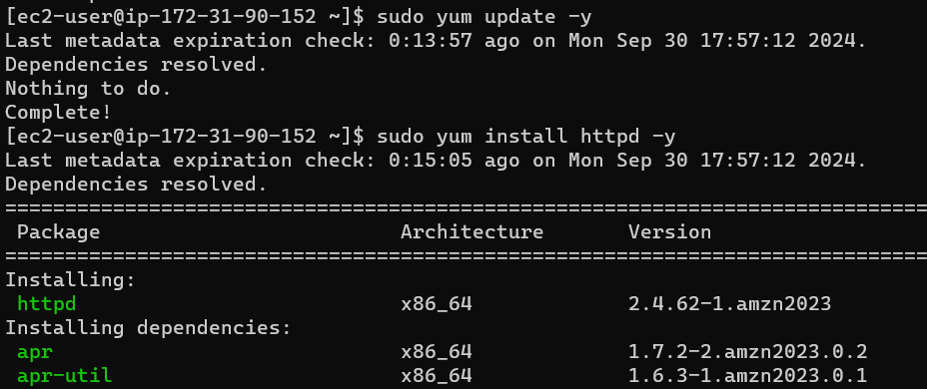If apache is not installed on your system:

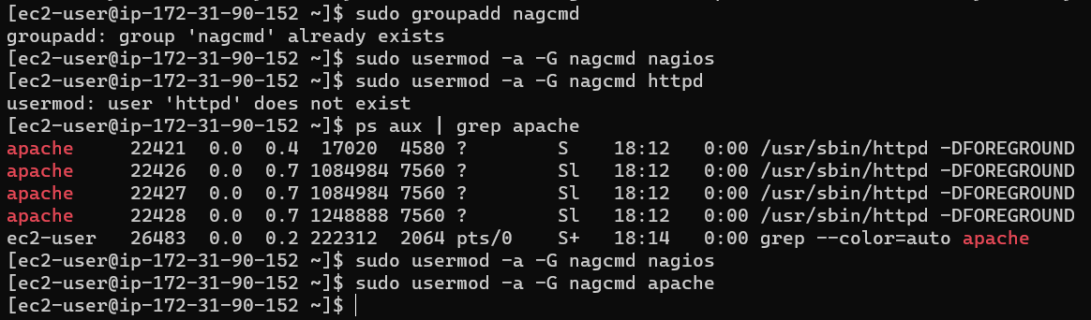

**Step 6:** Now make a new directory and go to that directory. mkdir ~/downloads cd

~/downloads

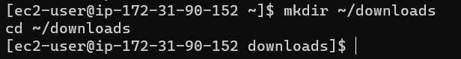

**Step 7:** Now to download the Nagios 4.5.5 and Nagios-plugins 2.4.11 run the following commands respectively.

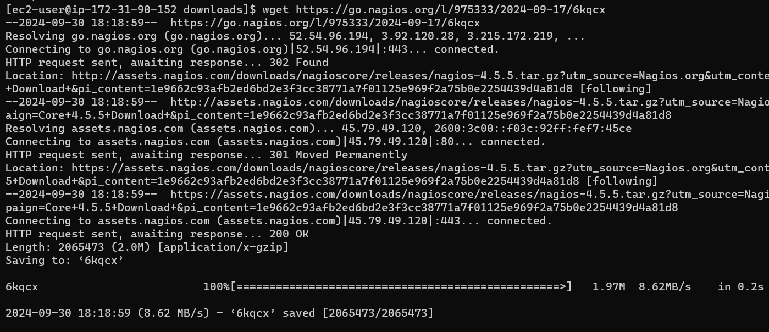wget <https://go.nagios.org/l/975333/2024-09-17/6kqcx>

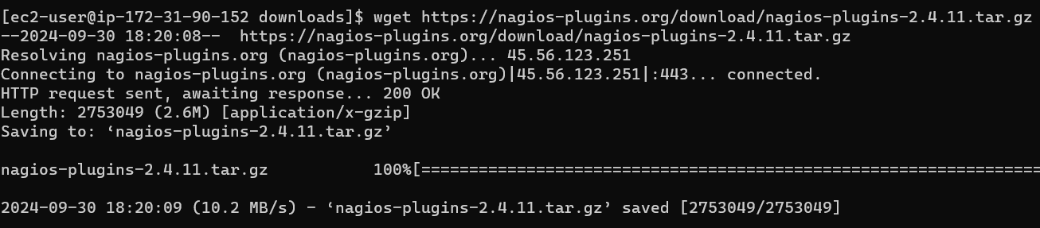wget <https://nagios-plugins.org/download/nagios-plugins-2.4.11.tar.gz>

**Step 8:** Now to extract the files from the downloaded Nagios 4.5.5 run the following command. tar zxvf 6kqcx

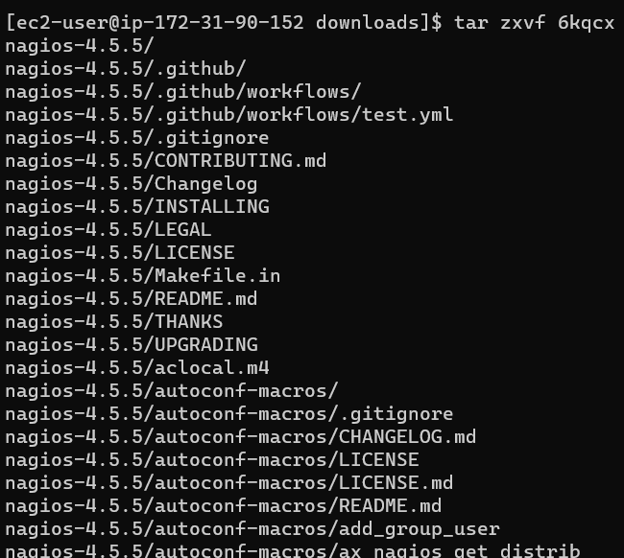

**Step 9:** Now change the directory to nagios-4.5.5

**Step 10:** Now run the following command to configure../configure

--with-command-group=nagcmd.

In this step you can get the error , it might be due to gcc is not installed in your system so to install it run the following command:**sudo yum groupinstall "Development Tools" -y**

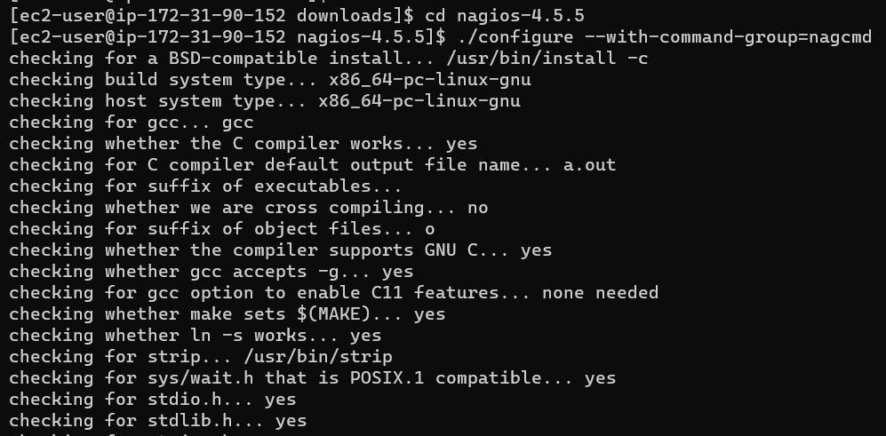

At the end we have found the error of cannot find ssl header .

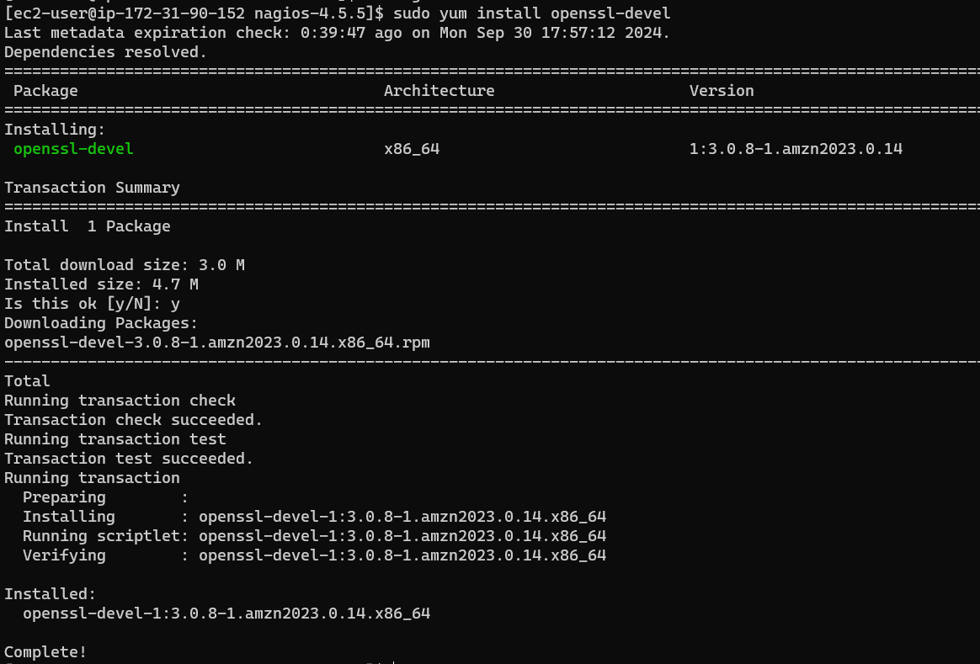So run following command to install ssl. sudo yum install openssl-devel

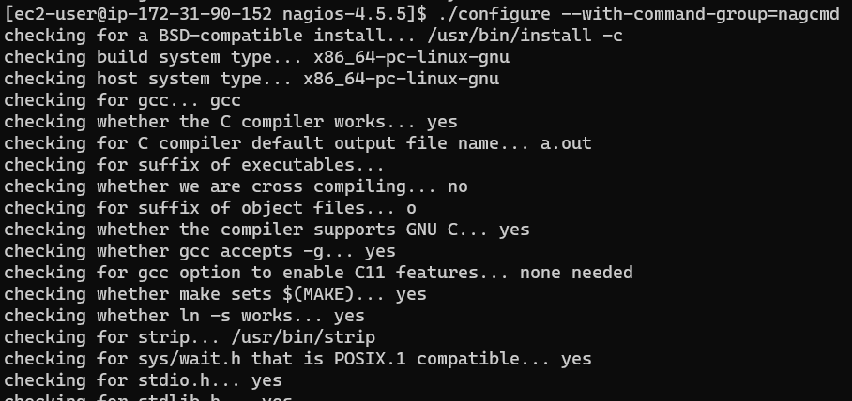Now rerun the command ./configure--with-command-group=nagcmd

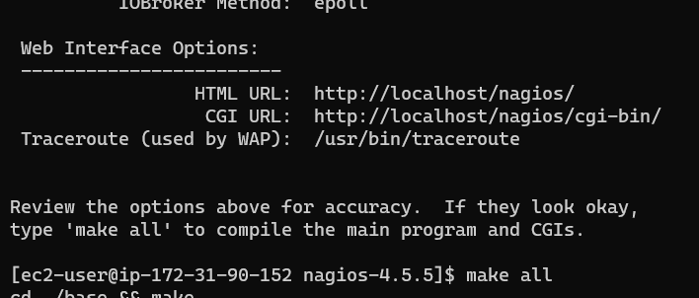

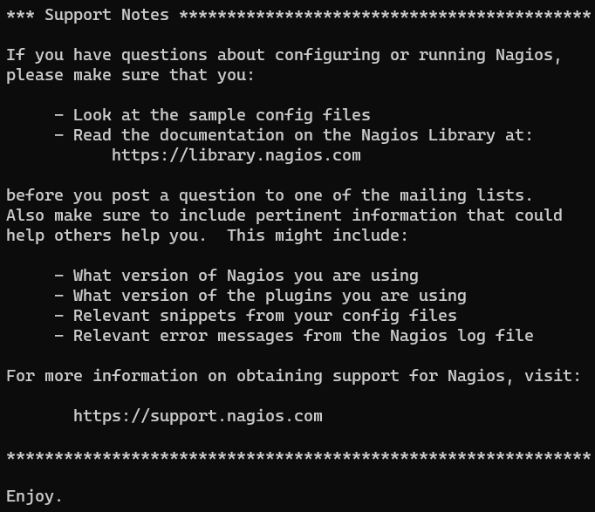

**Step 11:** Now run the following commands to steup the Nagios. sudo make install

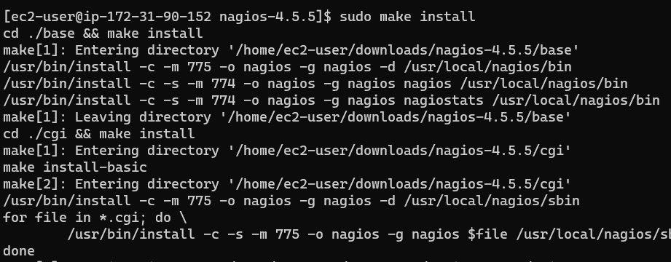

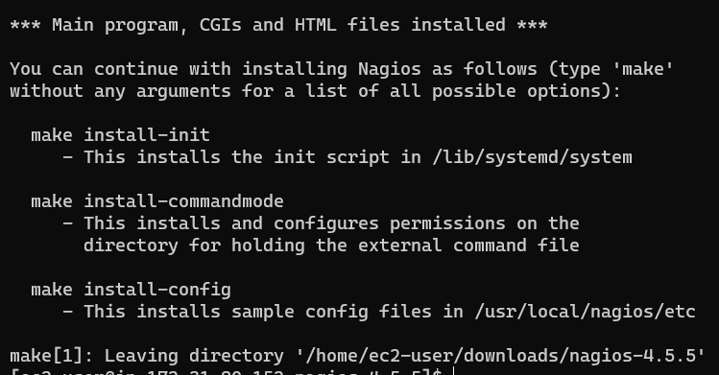

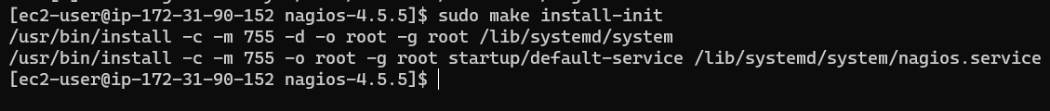sudo make install-init

sudo make install-config

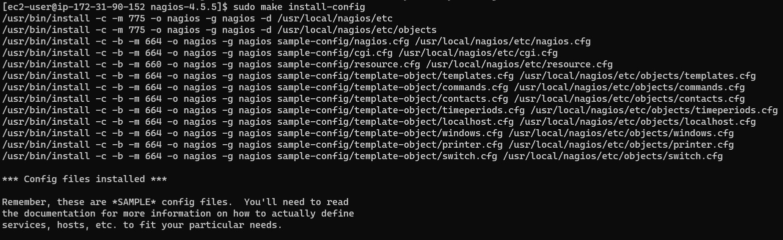

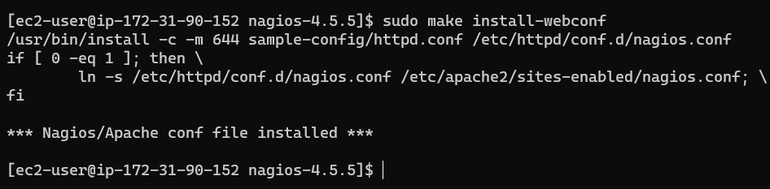sudo make install-webconf

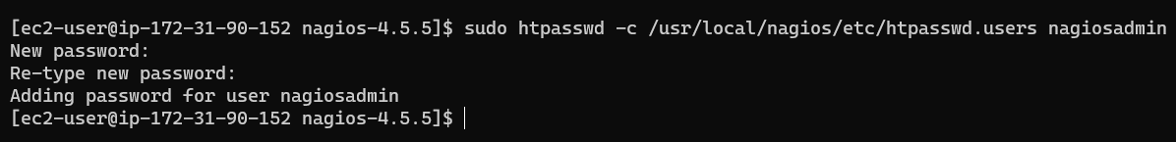sudo htpasswd-c /usr/local/nagios/etc/htpasswd.users nagiosadmin

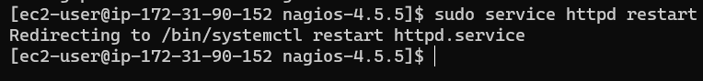Now to restart the httpd service run the following command. sudo service httpd restart

**Step 12:** Now to extract the files from the downloaded Nagios plugin 2.4.11 run the following command first change the directory.

cd ~/downloads

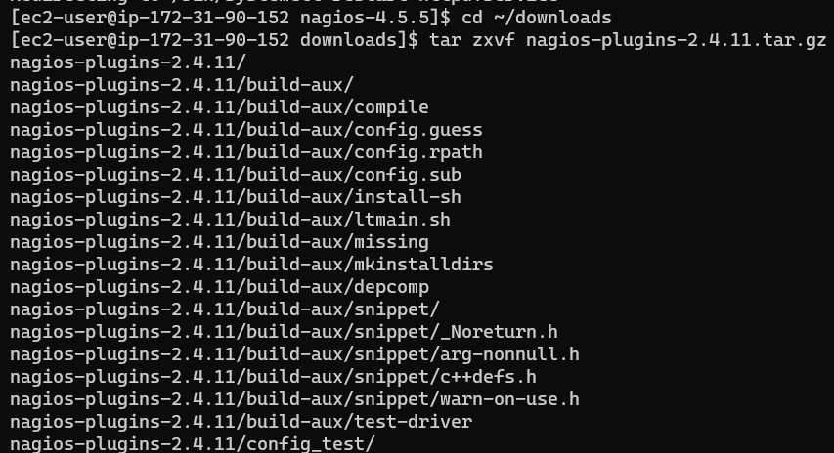tar zxvf nagios-plugins-2.4.11.tar.gz

**Step 13:** Now change the directory to nagios-plugins-2.4.11 and run the config command to configure.

cd nagios-plugins-2.4.11

./configure--with-nagios-user=nagios--with-nagios-group=nagios

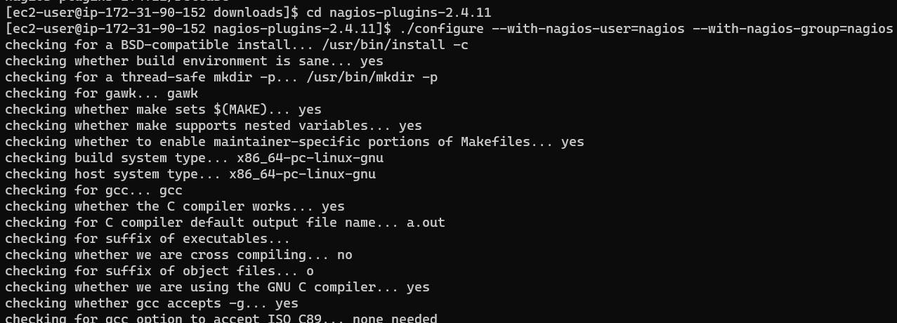

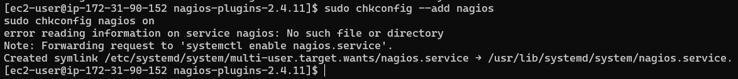**Step 14:** Run the following commands to check nagios and start it. sudo chkconfig--add nagios

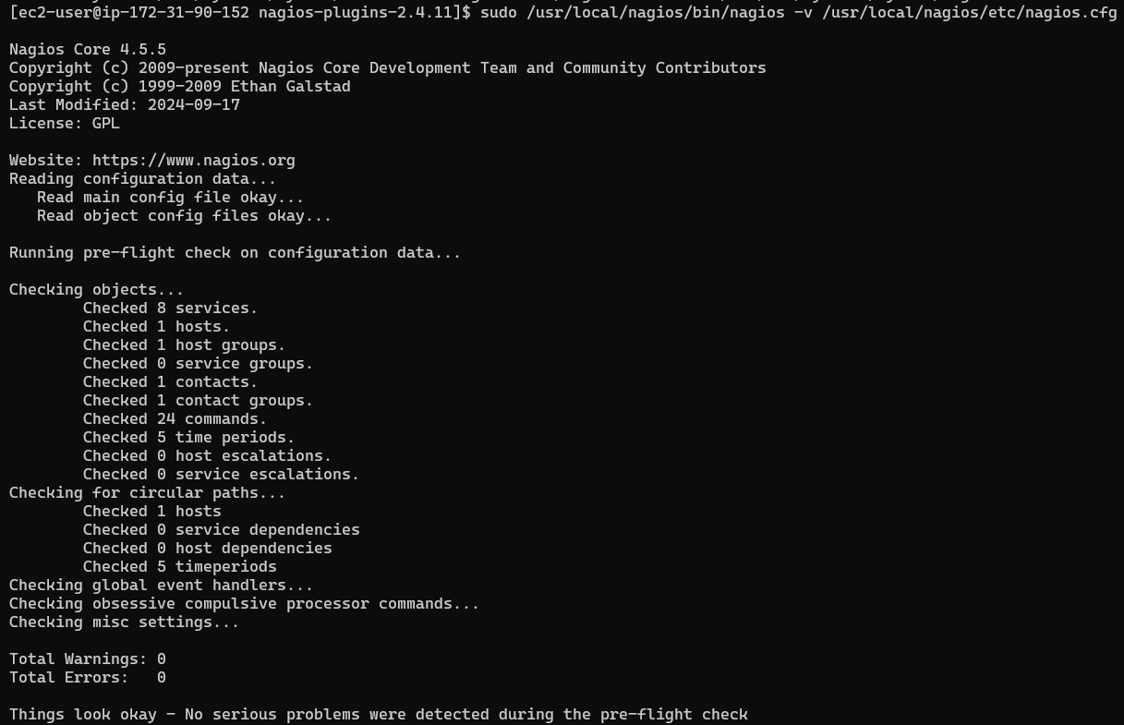sudo /usr/local/nagios/bin/nagios-v /usr/local/nagios/etc/nagios.cfg

cd

sudo service nagios start

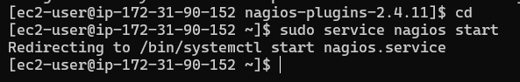

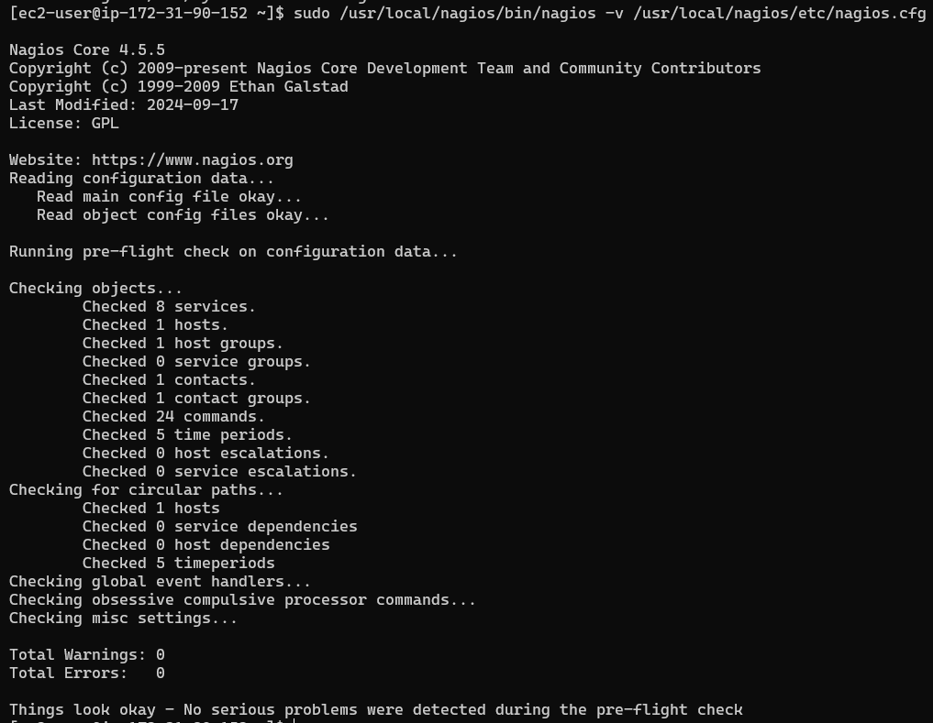sudo /usr/local/nagios/bin/nagios-v /usr/local/nagios/etc/nagios.cfg

sudo systemctl restart nagios sudo systemctl status nagios

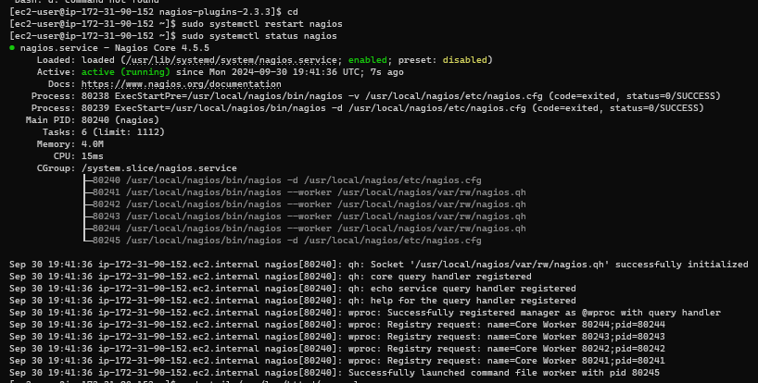

**Step 15:** We can see we have successfully launched the Nagios now . Open <http:///nagios/> here it is [**http://44.202.108.37/nagios**](http://44.202.108.37/nagios)we can see the running web page of nagios.

